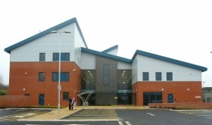

PLATT HOUSE SURGERY
Platt Bridge Community Health Centre
Rivington Avenue
Platt Bridge
Wigan
WN2 5NG

Medical Receptionist

Due to our rapidly growing patient list size and expansion of the practice,
we are looking to recruit an experienced medical receptionist.

The right candidate will be enthusiastic, flexible, and highly motivated. This is a demanding role, so the ability to work under pressure using own initiative is essential. We are a SystmOne practice, but full system training can be provided.

The hours of this post are negotiable between 24 -32 per week, worked over 4 days between the hours of 8:00am and 6:30pm
Starting rate (also negotiable) is £11.50 per hour.

If you are interested in applying for this post or would like more information, please contact the practice manager: katie.heyes@nhs.net

Closing date 24th January 2024

